Give the Gift of Health & Wealth…
Holiday Gift Ideas for Everyone in Your Life!

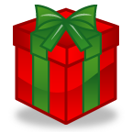

Athletic Types:
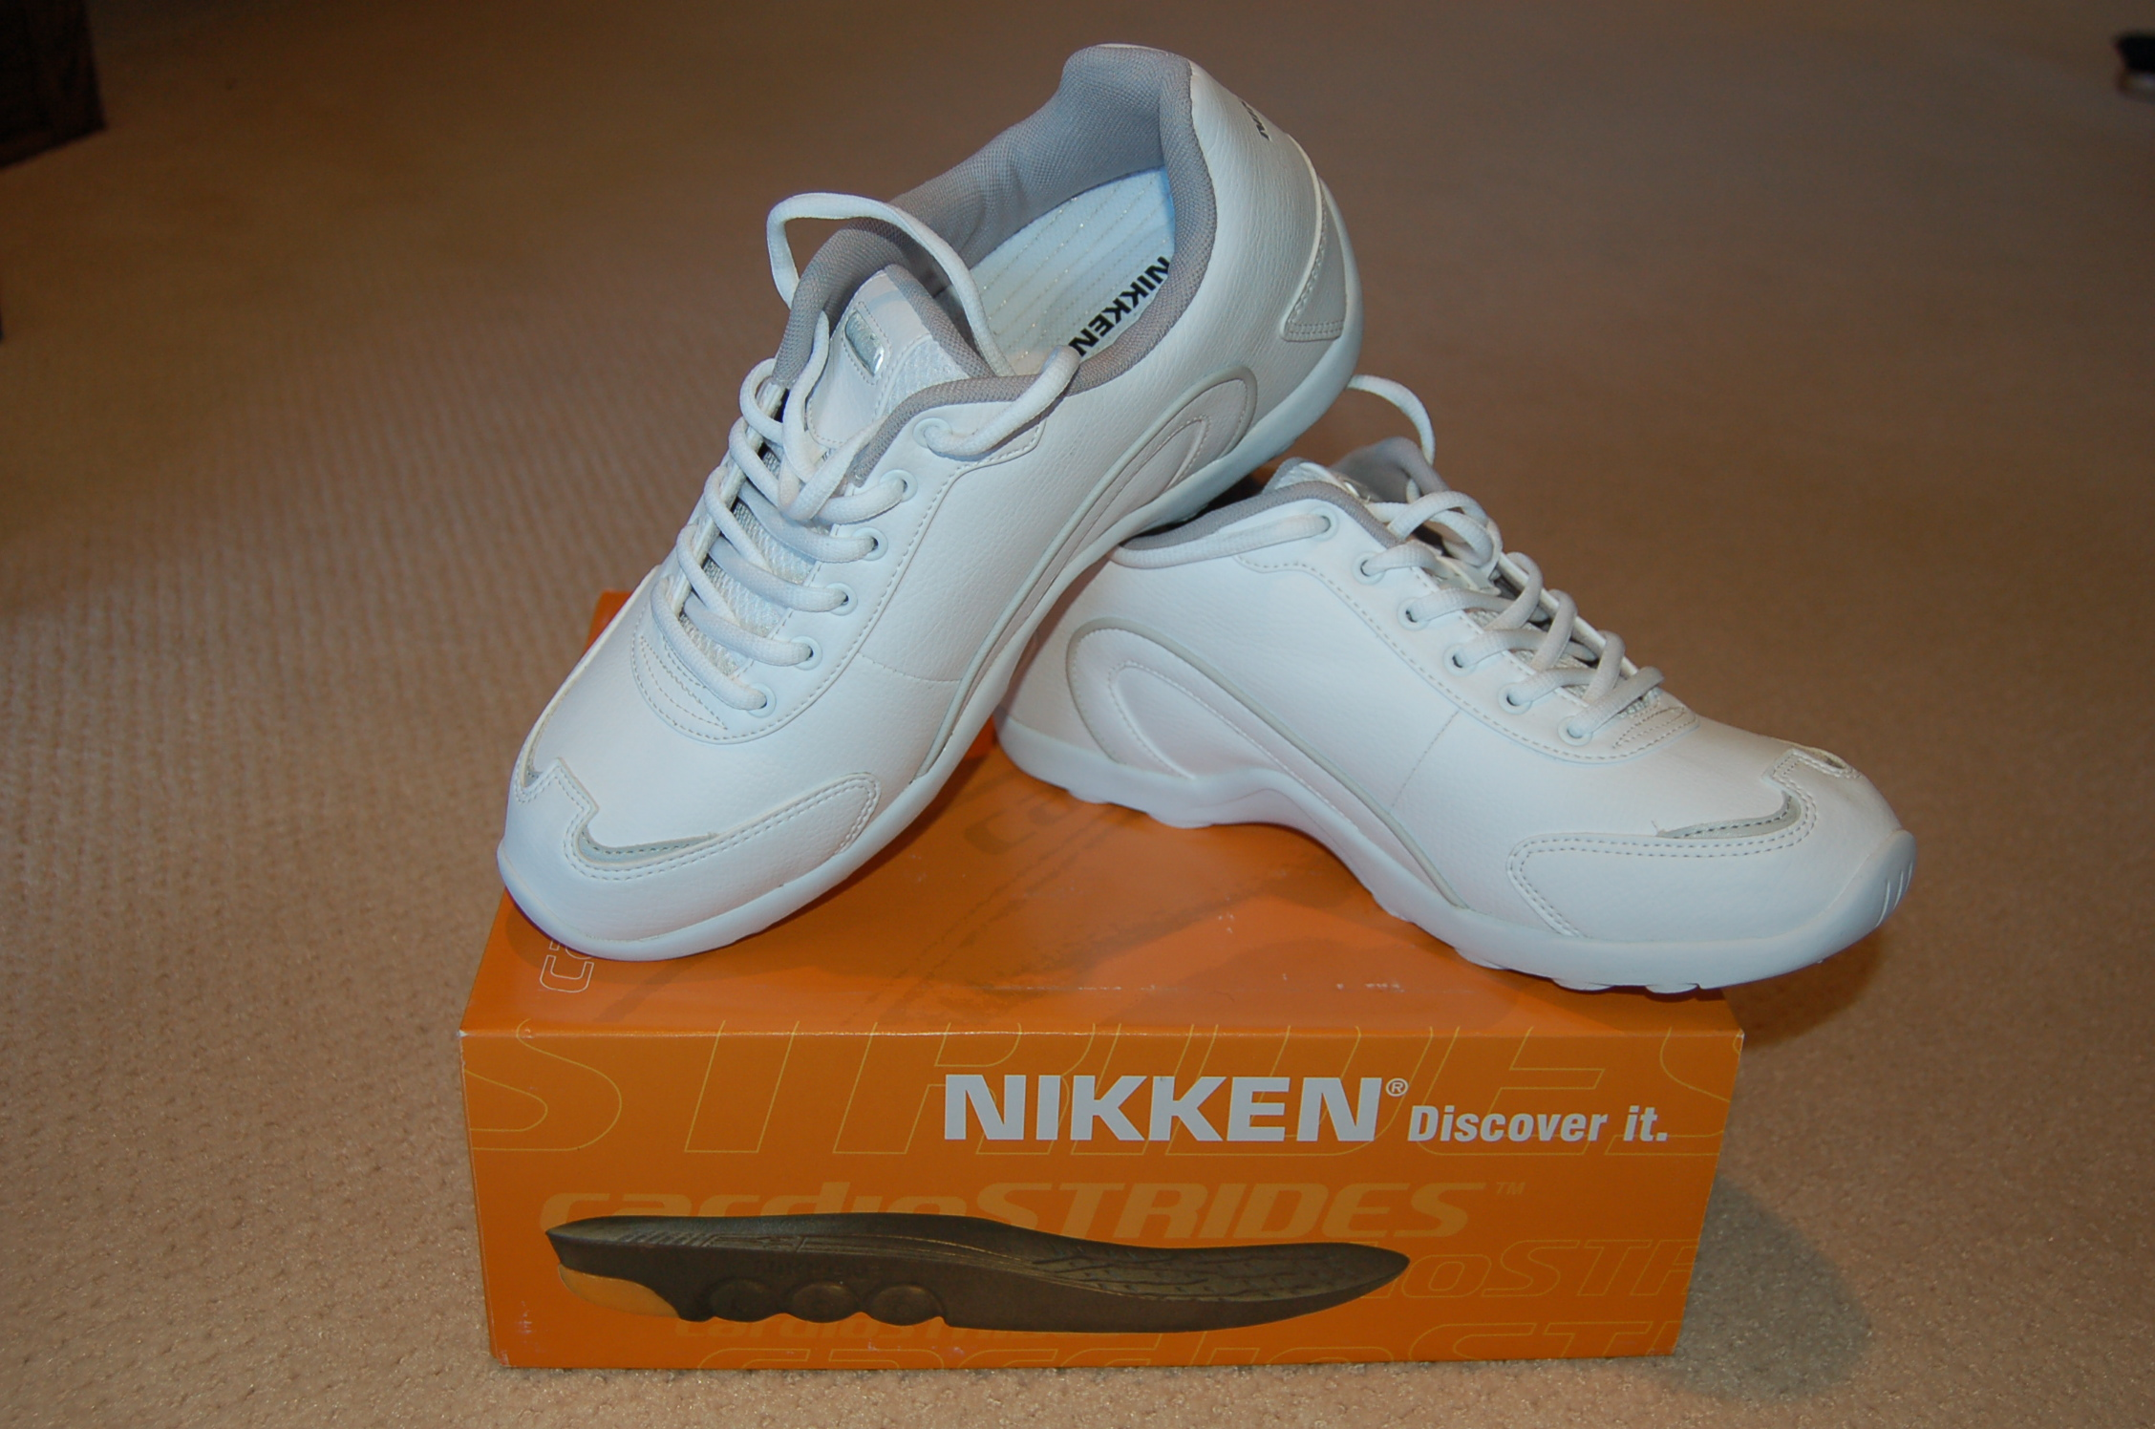
Wraps: Neck, Shoulder, Hand, Wrist,
Elbow, Thigh, Ankle, Back
Shoe inserts: MagSteps or Strides
Sport Socks, Sport Bracelets
Joint Formula & CM Cream
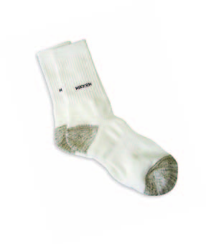
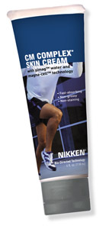
Healthy Living:
Nutrition: Organic Nutritionals,
Shower system & Water/Air filtration
To keep your body at its optimum.
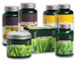
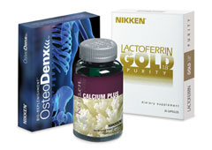
- Bone Health
- Anti-oxidants
- Ph Balance
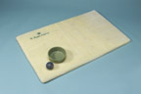
Pet Products:
Pet pads & nutritionals

Sitting at a Computer?
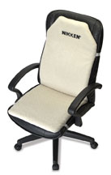
KenkoSeat, Wrist wrap, Back flex
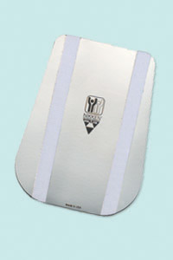
Bracelets, Body Energizer

Aches & Discomforts?
MagSteps/ Strides,KenkoSeat
Joint Formula & CM Cream
KenkoWave, Biaxial Powermag, Body Energizer
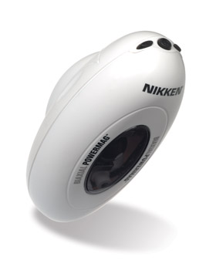
MagBoys, MagCreator
Kenko Power Patches
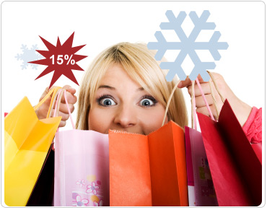

Accessories & Jewelry:
Women: Necklaces, Bracelets, Sport Socks
Men: Neck Chain, Bracelet, Sport Socks
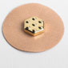
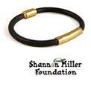

The Nikken Business Opportunity

Become a Consultant for $35 plus tax & shipping…receive 20% discount from wholesale. Share Nikken with others & Earn Cash, Car & Home
Power Patch!

June Silva
201-522-5134
www.mynikken.net/futurehealth
junesu

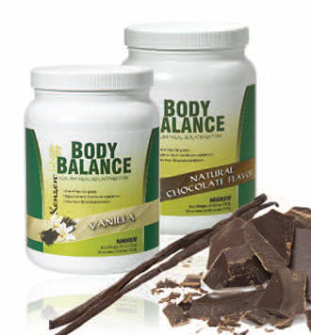
Shed Holiday Pounds:
Organic Meal Replacement,
CardioStrides,
PiMag Water,
Detoxifying Cleanse

Trouble Sleeping? State of the Art Sleep Solutions
Enhanced Magnetic Ram
Naturest Topper &
Pillow with new
RAM technology!
Technology mattress/pad/pillow,
Dream or Dream Deluxe pillow,
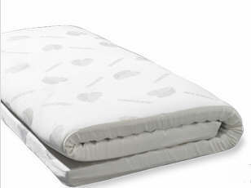
Comforters, Sleep Mask,
Travel Comforter
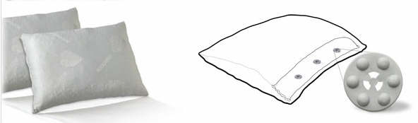

Skin Care:
True Elements™ Swiss Organic Skin Care products are made from the flowers, vines and herbs that grow in the Valaisan Mountains of the Swiss Alps. They are certified organic by Ecocert — a distinction that can be claimed by few skin care products, even many with “organic” on the label.
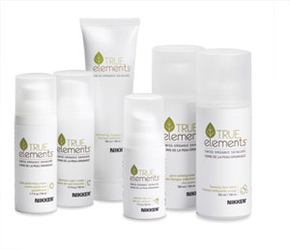

Jet Lag or Long Drives?
KenkoSeat ,Neck Wrap,
Necklace, Magboys

Energy Savers:
Magna Charger/Gasoline
Sleep Quilts/Utility Bills

There are so many people who are suffering today.
Why not give the gift of health! Give someone you love, a gift that will make a positive difference in their life this year. They will thank you many times over in the years to come!

