What Is Most Important In Your Life?

______________________________________________________________



INVEST IN YOUR HEALTH WELLNESS / SICKNESS PATH
WELLNESS
HOME

Financial Success Plan
Rest/Sleep System

Clean Energized Air

Living Water

Nutrients

Energy/Exercise

Fitness

Who Could Benefit From Using These Products?
_______________________ _______________________
_______________________ _______________________ _______________________ _______________________
www.allswellsolutions.com
If Your Yearly Income Became Your Monthly Income, What Would Change?
_________________________________________________________

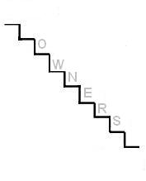



Who Do You Know That Needs To Make An Extra $1,000.00 or More Every Month?
__________________________ __________________________
__________________________ __________________________
__________________________ __________________________
www.allswellsolutions.com

