Kenko MStrides - Amazing Result in Seconds

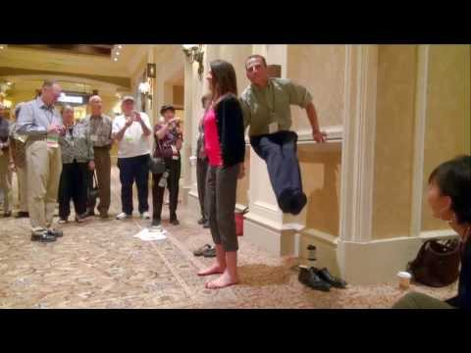 | Play video  This lady was able to support the 140lb man, Vance Rogers, when stepping on the Kenko MStrides. Truly amazing.  00:01:03  Added on 11/01/13  1,463 views | 
Here are some of my favorite short video's. Vance and Stacy have been friends with most of these people for years and Vance can tell you that they're just as excited today about Nikken as the day they experienced the solutions first hand over 20 years ago.

Joanna Wyatt - Personal Trainer looking for extra energy
https://www.youtube.com/watch?v=ts1QKQVRlTI

Kay Logan - Recovery from major traffic accident
https://www.youtube.com/watch?v=0VsVVTvwU88

Herb Rapp - Tennis pro praying to help his mom
https://www.youtube.com/watch?v=9UwhSo1cqlY

Dutch & Ruth VanKrieken - Parents with autistic son
https://www.youtube.com/watch?v=IIE5RnpzXms

Barbara Bertucci - Mom trapped in misery
https://www.youtube.com/watch?v=dos2IhMYFrk

In less than 20 minutes you'll get to hear stories of lives that have been changed for the better with simple modalities that God put in the earth for us to use every day. So often though, our lives get too busy to enjoy what's around us because we can't get outside to absorb magnetics, pure sunlight, negative ions, or even clean water. Nikken brings all these elements inside for us to enjoy while we sleep, walk, breath, eat, drink and pretty much do everything.

Vance met the founder in ’94 in an elevator and was more than impressed with his passion for people. He’s retired from running the show, but his philosophies are still front and center. Approaching 40 countries with over 25 billion in sales, they estimate around 40 million people have been impacted by the simple solutions.

Look forward to connecting again soon,

Carol and Steve

PS If you want to poke around a little more, here is our website: http://allswellsolutions.com
Our Partner’s, Vance and Stacy’s, website is: http://www.nikken.com/vancestacey

mStrides demo
https://www.youtube.com/watch?v=iCWYlKTZW4I

