Drink from a Clean, Safe, Environmental Friendly, Energized, Alkaline, Nikken Pi Mag Water Bottle …

FILL UP 1 NIKKEN WATER BOTTLE FOR A YEAR OR
BUY 1600 ½ LITRE (Store Bought) BOTTLES with NO extras !

YOU CHOOSE !!!

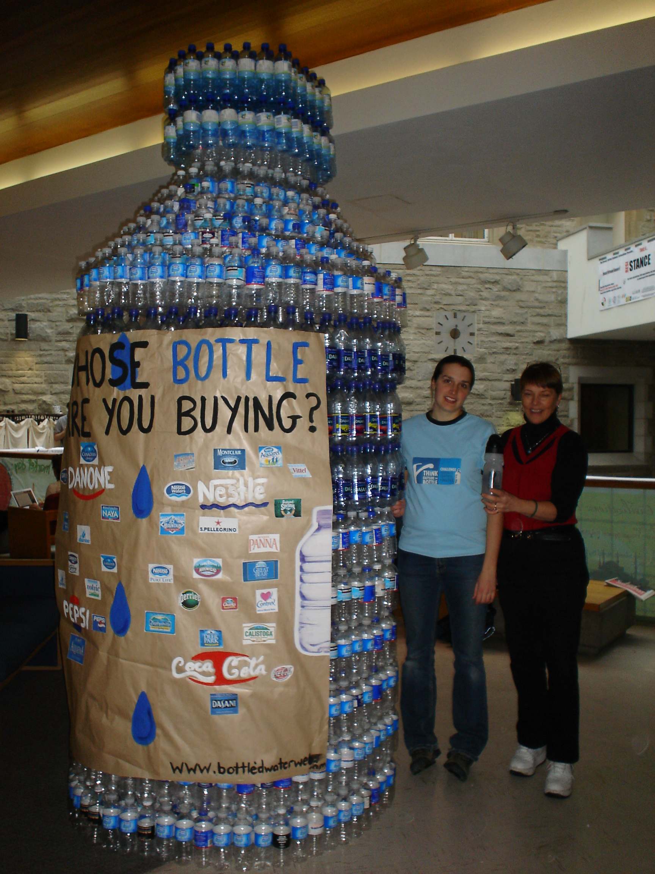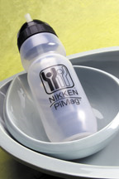

NIKKEN IS GOOD FOR YOU, YOUR WALLET & THE ENVIRONMENT

Contact Nikken Independent Wellness Consultant
RitaSue Bolton at 613-549-4075
www.mynikken.net/sherenergy

