1. "Congress finds that there is a link between the ingestion of certain nutrients or dietary supplements and the prevention of chronic diseases such as cancer, heart disease and osteoporosis.” They've finally discovered and admitted what many of you have known for years!
2. “Congress finds that the importance of nutrition and the benefits of dietary supplementation to health promotion and disease prevention have been documented in scientific studies.” US Law 103-417 - The Dietary Supplement Health and Education Act
The United States Department of Agriculture Reports...

3. “92% of Americans do NOT get the required daily allotment of nutrients from the food they eat. We're sure we're in that 92%. How about you?
4. Commercially grown and processed foods may be deficient in vitamins and minerals. With the depleted soils today, don't you agree, this is a true. When I was raised on a farm, we rotated crops to replace the natural losses organically. For example, we rotated Alfalfa fields with the corn fields. Corn depletes the Nitrogen in the soil, Alfalfa has deep roots with Nitrogen Nodules that replace nitrogen into the soil. Today, if farmers do anything, it's mostly done with chemicals instead of organically.
5. The US Government's new Food Pyramid recommends 9 to 11 servings of fresh fruits and vegetables every day. We don't do this. Do you know of anyone who does? Even if they did, would the food be organic and have the needed nutrients?
_______________________________
Introducing the Nikken Power of 5 CIAGA Juice.
- Ciaga Quick Reference Sheet - PDF
- Ciaga Ingredients - PDF
- ORAC Chart - PDF
For a better understanding of the health benefits of CIAGA, below are some specific questions that relate to the efficacy of the product and detailed descriptions of each ingredient.
in this issue
• Whole-Foods Revolution Begins
• What is CIAGA?
• What is the nutritional value of Pomegranate?
• What is the nutritional value of Aloe Vera?
• What is the nutritional value of Goji Berry (Wolfberry)?
• What is the nutritional value of Blueberry?
• What is the nutritional value of Montgomery Red Cherry?
• What is the nutritional value of Noni?
• What is the Nutritional Value of Green Tea Extract?
• What is the nutritional value of Brown Rice Extract?
• What is the nutritional value of Red Rice Extract?
• What is the nutritional value of Beta Sitosterol?
• What is the nutritional value of Rhodiola Rosea?
• What is the nutritional value of Red Ginseng Root (Panax Ginseng Root)?
• What is The nutritional value of Jujube Fruit?
• Specific Questions About CIAGA Juice

What is CIAGA?
CIAGA has five (5) key components that will be referred to as "The Power Of 5":
- C ardiovascular Support - A unique combination of Brown Rice Extract, Red Rice Extract, and Beta SitoSterol to aid in heart health and immune system health.
- I mmune Support - This unique blend of Aloe Vera and Noni juices and Green Tea extract is a powerful combination for building and supporting a healthy immune system.
- A nti-Oxidant Support - Pomegranate, Blueberry, Goji Berry, Orange, Mandarin, Raspberry and Green Tea.
- G astrointestinal/Digestive Support - consisting of Pomegranate, Cherry, Blueberry, Noni, Aloe Vera and Goji (Wolfberry) juices.
- A doptogenic Support - A unique combination of Rhodiola Rosea and Red Ginseng Root Extracts to increase the body's ability to adapt to environmental and internal stress.

What is the nutritional value of Pomegranate?
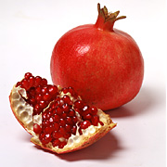
Pomegranates are packed with antioxidants, including Anthocyanins and Ellagic acid. According to clinical research, Ellagic Acid may be one the most potent ways to fight cancer. Ellagic Acid, a phenolic compound, is a proven anti- carcinogen, anti-mutagen, and anti-cancer initiator.
Modern studies have shown that just 2 ounces of pomegranate juice daily keeps the cardiovascular system, including arteries, plaque-free and healthy. Scientists attribute the anti-artheriosclerotic properties of pomegranates to the antioxidant polyphenols. In addition to polyphenols, pomegranates contain several other antioxidants, including vitamin C that may contribute to its antioxidative and antiatherogenic effects. Pomegranate juice is a major source of polyphenolic flavonoids and is the most potent antioxidant protecting against LDL oxidation and atherosclerosis.

What is the nutritional value of Aloe Vera?
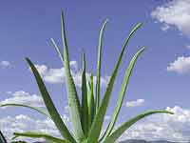
Aloe Vera is rich in polysaccharides, complex carbohydrates that boost the immune system and support a healthy digestive system. Research indicates that aloe facilitates digestion, aids in blood and lymphatic circulation, as well as kidney, liver and gall bladder functions. Aloe contains at least three anti-inflammatory fatty acids that are helpful for the stomach, small intestine and colon. It naturally alkalizes digestive juices to prevent over-acidity - a common cause of indigestion. It helps cleanse the digestive tract by exerting a soothing, balancing effect.
A newly discovered compound in aloe, acemannan, is currently being studied for its ability to strengthen the body's natural resistance. Studies have shown acemannan to boost T-lymphocyte cells that aid the immune system.

What is the nutritional value of Goji Berry (Wolfberry)?
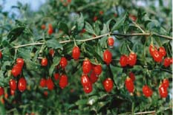
These berries flourish in the tranquil valleys that are naturally protected by the Himalayan Mountains. The nutrient-rich soil and the fresh mountain air guarantee nearly perfect conditions for the plant to blossom.
The Goji Berry (Wolfberry) is the most nutritionally dense food on this planet. It contains:
- 19 amino acids, including 8 that are essential for life
- 21 trace minerals, including germanium, a trace mineral rarely found in foods
- More protein than whole wheat
- A complete spectrum of antioxidant carotenoids including beta-carotene and zeaxanthin (protects the eyes). Gram for gram, Goji is the richest source of carotenoids in all known foods!
- More vitamin C than oranges
- Vitamin E, which is rarely found in fruits
- B-complex vitamins, needed to convert food into energy
- Beta-Sitosteral, an anti-inflammatory agent
- Essential Fatty Acids
- Cyperone, a sesquiterpene
- Solavetivone, a powerful anti-fungal and anti-bacterial agent
- Physalin, which boosts the immune system
- Betaine, which is used by the liver to produce choline
- Bioactive polysaccharides, called proteoglycans
- Plus 4 unique polysaccharides not found in any other plant substance on earth
The Goji Berry is enriched with naturally occurring minerals (Zinc, Calcium, Germanium, Selenium, Phosphorus, Copper and Iron). Goji Berry is also a natural source of antioxidant vitamins. It contains four unique polysaccharides and phytonutrient compounds that work in the body to neutralize free radical cell damage. These polysaccharides are "master molecules" that command and control many of the body's most important defense systems and encourage good overall health.
For example:
- Immunity: Polysaccharides from Goji Berries have been found to be effective in effectively treating hypertension, gastrointestinal disorders and periodontal disease.
- Allergies: Goji was found to be effective in reducing antibodies associated with allergy-type reaction and in alleviating the discomforts of psoriasis.
- Anti Aging: Goji's unique LBP Polysaccharides complex has been found to be highly effective in stimulating the natural secretion of human growth hormones
- Anti Cancer: Goji LBP Polysaccharides have been particularly active of enhancing the production of Interleukin-2 (IL-2), a cytokine (cell protein) that induces potent anti-tumor responses in a variety of cancer models.
- Obesity: Goji LBP Polysaccharides enhance the conversion of food into energy, improve general metabolism and reduced body weight.

What is the nutritional value of Blueberry?
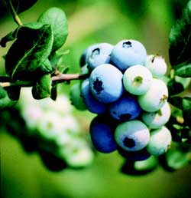
Packed with health-promoting phytochemicals, blueberries have the power to keep you healthy. Though small in size, blueberries are packed with antioxidants that may help your body fight everything from the effects of aging to vision problems to cancer. Blueberries contain more disease-fighting, age-proofing antioxidants than practically any other fruit or vegetable, even powerhouses such as kale, broccoli, and oranges.
In fact, blueberries were at the top of the list of 40 fruits and vegetables tested for their antioxidant potential. The group of substances that put the "blue" in blueberry- Anthocyanins - are probably responsible for much of the fruit's antioxidant power. Blueberries (like other berries such as blackberries) also contain ellagic acid, which as stated above, has been shown to have anti-cancer properties.
Blueberries also boast a high fiber content; much of that fiber is pectin, a soluble fiber that helps lower cholesterol levels.
Phytochemicals contained in blueberry juice are also known to relieve arthritis pain, promote urinary tract health, fight infection, aid in the prevention of heart disease and stroke, guard against Alzheimer's and neurological diseases and combat aging and short- term memory loss.

What is the nutritional value of Montgomery Red Cherry?
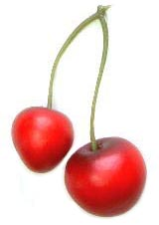
Montmorency Red Cherry Juice is one of nature's most nutritionally dense foods containing a wide variety of powerful antioxidants and phytochemicals. Rated as one of the highest on the ORAC scoring chart, Red Cherry juice has been shown to substantially reduce the risk of coronary heart disease, cancer, and other age related illnesses.
Additionally, Cherry Juice contains melatonin, which may help in the promotion of proper sleep. Red Cherry juice has anti-inflammatory anthocyanins and bioflavonoids that may assist the body to relieve pain associated with arthritis and gout. Isoqueritrin and queritrin (flavonoids) are part of the phytochemical profile that assist the body in eliminating by-products of oxidative stress thereby slowing the aging process.
Cherry juice is certainly one of nature's most powerful cell rejuvenating antioxidants!

What is the nutritional value of Noni?
Noni juice is the juice of the fruit of Morinda citrofolia grown in Polynesia. Nearly every part of the noni plant is valuable. Doctors and scientists believe that xeronine and other nutracenticals found in Tahitian Noni are vital for long-term cellular health. "Xeronine" is an alkaloid found in healthy human cells. This chemical is essential to healthy cell function and cell regeneration.
Noni juice contains high amounts of vitamin C, minerals, carbohydrates, enzymes, anti-oxidants, phytonutrients, boiflavonoids, proxeronine, and scopoletin. In fact, including naturally occurring vitamins and minerals, there are 60 known phytonutrients in the Noni fruit.
These nutrients contribute to the following:
- Immune system: supports the immune system to fight disease and infection.
- Circulatory system, tissues, and cells: Noni juice is a superior antioxidant that helps rid the body of harmful radicals, and increases energy levels.
- Digestive system: supports proper digestion and helps you absorb more nutrients at the cellular level.
- Skin and hair: Noni juice contains components that are specifically important to the skin and hair.

What is the Nutritional Value of Green Tea Extract?
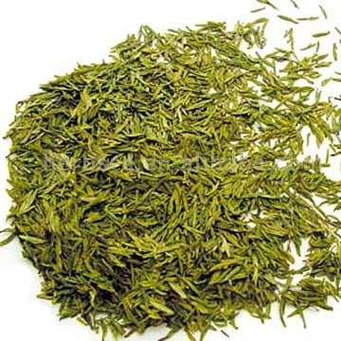
Green tea is noted for its anti-cancer effects, as well as its ability to aid in weight-loss. The active constituents in Green Tea are a family of polyphenols (catechins) and flavonols which possess potent antioxidant activity.
Catechins belong to the flavan-3-ol class of flavonoids. Green tea catechins are the flavan-3-ols found in green tea leaves. Several classes of catechins are present in Green Tea with significant quantities called epigallocatechins gallate (ECGC). ECGC appears to be the most powerful of the catechins with an antioxidant activity from 25 to 100 times more potent than vitamin C and E.
Incidentally, the green tea extract that we use is caffeine free. Clinical research has determined that Green Tea will provide the following health benefits:
- Increased energy & vitality
- Weight loss
- Reduces risk of cancer, heart attack, stroke, diabetes, heavy metal toxicity
- Boost immune functions to better combat infections & flu
- Help fight aging, dental decay, and more
- Ailment specific herbal formulas
- Enhance, protect, and restore vital functions of the body
- Preventative maintenance for health and longevity

What is the nutritional value of Brown Rice Extract?
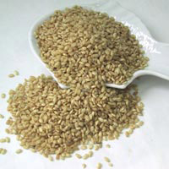
Brown Rice Extract is nutritionally diverse. The tocotrienols in Brown Rice help in maintaining the anti-inflammatory properties inherent to Vitamin E for those suffering from any type of chronic pain disorder. Brown Rice Extract contains superior forms of vitamin B complex, which is crucial for energy metabolism. Containing Lipoic Acid, Brown Rice Extract is an essential key to normalize healthy blood sugar levels.
It can also help protect the body against the damage that can cause heart disease, cancer, aging, strokes, arthritis and many other degenerative diseases. There are many fatty acids found in Brown Rice Extract that can help improve some skin disorders such as eczema or psoriasis. These fatty acids also help in the normal function and development of the brain. All of the essential amino acids are contained in Brown Rice Extract.
Amino acids are required to form the brain's neurotransmitters which are the chemicals that permit our brain to receive and transmit messages. It is the presence of these amino acids that insure the proper assimilation of vitamins and minerals.

What is the nutritional value of Red Rice Extract?
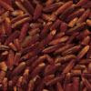
Red Rice Extract is an Asian product developed by fermenting rice with Monascus Purpureus, otherwise known as red yeast. Red Rice Extract restricts the amount of cholesterol produced by the liver. It raises HDL, lowers LDL and also lowers triglyceride levels. By lowering cholesterol concentrations, Red Rice Extract may help to prevent heart disease and some of its complications.

What is the nutritional value of Beta Sitosterol?

As one of several phytosterols (plant sterol compounds with chemical structures similar to that of cholesterol), beta-sitosterol, a white waxy substance, is commonly found in foods such as wheat germ, soybeans, and corn oil. Over the past few years, concentrated extracts of this particular phytosterol have been tested for lowering cholesterol and lessening such discomforts of benign prostatic hyperplasia (BPH) accompanied by frequent and painful urination.
Research indicates that beta-sitosterol may lessen inflammation and block the accumulation of cholesterol in the prostate gland itself. Beta- sitosterol may also lower elevated cholesterol in some cases, a function of its apparent ability to block the absorption of cholesterol throughout the body.

What is the nutritional value of Rhodiola Rosea?
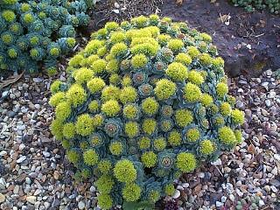
Rhodiola Rosea is an adaptogen. The main effects of adaptogens are an increased availability of energy during the day, a reduction of stressed feelings, increased endurance, greater mental alertness, and deep and restful sleep. Also, adaptogens significantly accelerate the recovery process after illness.
According to modern science, adaptogens are natural plant products that increase the body's ability to cope with internal and external stress factors, and normalize the functions of the organism. They help maintain the stable internal environment inside the organism known as homeostasis. An important characteristic is that they are safe, possessing few known side effects.
Rhodiola Rosea has revealed the presence of six distinct groups of phytochemical compounds:
- Phenylpropanoids: rosavin, rosin, rosarin
- Phenylethanol derivatives: salidroside (rhodioloside), tyrosol
- Flavanoids: rodiolin, rodionin, rodiosin, acetylrodalgin, tricin
- Monoterpernes: rosiridol, rosaridin
- Triterpenes: daucosterol, beta-sitosterol
- Phenolic acids: chlorogenic and hydroxycinnamic, gallic acids

What is the nutritional value of Red Ginseng Root (Panax Ginseng Root)?
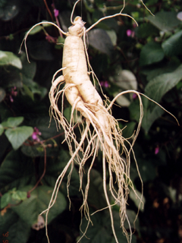
Approximately 29 ginsenocides, known by their scientific name "tripterpenoid saponins" and also sometimes called panaxosides, have been identified in ginseng root. These ginsenocides have been demonstrated to have a powerful function as an adaptogen, invaluable in helping the body adapt to and recover from the effects of stress, disease, and fatigue. They also contain a strong anti-oxidant component that has been shown in clinical studies to aid in combating the effects of aging.
Additionally, saponins are analgesic, anti- inflammatory, anti-convulsant, and a regulator of blood sugar levels, cholesterol levels, and blood pressure. Ginseng also contains several steroid compounds, including panaxtriol. The steroid components contained in Ginseng are remarkably similar to anabolic steroids found naturally in the human body. With anti-fatigue action, Ginseng Root is ideal for athletes and body builders looking for safe natural alternatives to anabolic steroid use. Ginseng has also been shown to be an effective immune enhancer and a metabolic accelerator.

What is The nutritional value of Jujube Fruit?
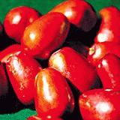
This special fruit, sometimes called the "red date," has been used since ancient times as a nutrient tonic, a blood cleanser, and as an important adjunctive herb to other tonics, especially in combination with Ginseng. Jujube, which is not a true date, is believed to build strength and increase energy. In traditional Chinese medicine, Jujube Fruit (Ziziphus jujuba, v. spinosa) is widely used as a sedative herb for calming, as well as nourishing the blood, spleen and liver. The fruit and seed extract has been shown to calm, relax, reduce stress, conserve energy, and promote sleep. It's a great fruit extract for those with symptoms of nervous exhaustion, fatigue, irritability and the inability to sleep. It is also analgesic. A non-toxic fruit, Jujube is extremely beneficial for the liver.

Specific Questions About CIAGA Juice
Does CIAGA need to be refrigerated?
Refrigeration ensures that the freshness, quality and integrity of CIAGA are maintained at all times. Refrigeration allows wellness consultants to experience the best tasting and healthiest combination of juices that have ever been produced.
Why is the bottle blue?
Actually the blue bottle gives a very pleasing high quality appearance. However, the main reason for packaging in dark blue bottles is to protect the nutrient and antioxidant integrity from any potential ultra-violet ray damage. Our goal is to provide the most potent and efficacious product possible.
Is the Nikken Health drink Kosher?
Yes. Look for the kosher symbol (ou) on the bottles.
How Much of the Nikken Health Drink should I take?
- If you are young and healthy, then one ounce (30 ml) a day should be adequate.
- As you grow older, two ounces a day (2 x 30mls), morning and late afternoon, will be appropriate.
- For therapeutic approach, consider taking 4 ounces a day (2 x 60 mls) for the first month.
- If you have a sudden traumatic incident or are about to face one (i.e., surgery) then 6-8 ounces would be appropriate taken at regular intervals during the day (3 or 4 x 60mls).
- For serious chronic conditions ( cancer) it may be better to take the same amount (6-8 ounces) in smaller doses more frequently (8 x 30mls).
- In life threatening conditions, take up to 16-20 ounces a day, divided into hourly doses.
Can diabetics safely take the Nikken Health Drink?
As it pertains to personal medical conditions, you should first consult with your physician or health care specialist. There are 4 grams of sugar per ounce. As a general rule, 1 to 4 ounces per day should be acceptable.
Can children safely take the Nikken Health Drink?
Yes. Children should drink up to ½ ounce per day.

